TTSK-FZ-10AB

Technical Specifications for Vehicle-Mounted Drone Detection and Defense Equipment

Table of Contents
1. Overview 3
2. Equipment Overview 3
2.1 Equipment View 3
2.2 Product Model 4
2.3 Equipment Usage 4
2.4 Technical Specifications 4
3. Equipment Features and Functions 6
4. Device Structure and Components 6
4.1 Six-views of the Product 7
4.2 Product List 7
5. Equipment Interface 8
5.1 Equipment Operation Interface 9
5.2 Equipment Safety Protection 9

1. Overview
With the rapid development and widespread adoption of drone technology, drones have shown great potential in areas such as aerial photography, agriculture, rescue operations, and security. However, this growth has also introduced increasing safety concerns. Incidents of illegal intrusion, malicious reconnaissance, and privacy violations are becoming frequent, posing serious threats to national security, public safety, and personal privacy. Therefore, developing efficient and advanced counter-drone technologies has become an urgent need to maintain airspace security and ensure social stability.

2. Equipment Overview
The vehicle-mounted integrated drone detection and countermeasure system is designed for drone detection, identification, and counteraction. The system integrates multiple technologies such as radio detection, protocol decoding, and spectrum scanning. By utilizing the characteristic signals received from drones, it enables detection and identification of unauthorized drones. Through radio interference and jamming technology, the system provides low-altitude security protection for surrounding convoys within a 3km radius, even at high speeds of up to 150 km/h.

2.1 Equipment View
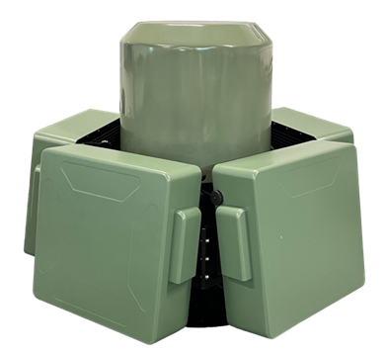
Picture：Vehicle-Mounted drone detection and defense equipment

2.2 Product Model

TTSK-FZ-10AB

2.3 Equipment Usage
The vehicle-mounted integrated drone detection and countermeasure system is a comprehensive security solution that combines drone detection, identification, and countermeasure capabilities. It is specifically designed to address the increasingly complex threats posed by drones. The system can detect drone activity in the surrounding airspace in real-time, quickly identify the type and flight path of the drone, and effectively suppress illegal intrusion or malicious activities through multiple countermeasures, ensuring the security of critical areas or events.

2.4 Technical Specifications
No. | Name | Performance Indicators.
1 | Detection Mode | Passive detection, does not actively emit radio signals in detection mode
2 | Detection Frequency | 300MHz~6GHz
3 | Detection Angle | Horizontal 0°~360°, vertical -90°~90°
4 | Detection Altitude | 0～1200m
5 | Detection Radius | 5km（subject to variation depending on environment and drone model）
6 | Detection Time | ≤5s
7 | Detection Power Consumption | ≤100W
8 | Jamming Distance | 3km（subject to variation depending on environment and drone model）
9 | Jamming Angle Selection | Allows independent on/off control for multiple angles
10 | Jamming Range | Horizontal: 360°; vertical: -90° to +90°.
11 | Jamming Frequency Bands | 900M/1.2GHz/1.5GHz/2.4GHz/5.2GHz/5.8GHz
12 | Operating Frequency | Channel 1: (840±15) MHz to (930±15) MHz  Channel 2: (1535±15) MHz to (1635±15) MHz  Channel 3: (2380±15) MHz to (2520±15) MHz  Channel 4: (5130±15) MHz to (5370±15) MHz  Channel 5: (5725±15) MHz to (5885±15) MHz  Channel 6: (1080±15) MHz to (1200±15) MHz
13 | Transmission Power | Channel 1: (47±3) dBm  Channel 2: (44±3) dBm  Channel 3: (47±3) dBm  Channel 4: (44±3) dBm  Channel 5: (47±3) dBm  Channel 6: (44±3) dBm
14 | Jamming Response Time | ≤3s
15 | Suppression Distance Ratio | The maximum distance ratio between the system and the drone versus the drone and its controller should be no less than 15:1 in the absence of significant electromagnetic interference
16 | Total Power Consumption | ≤2300W
17 | Mobile Power Supply | Mobile power supply; in full-frequency transmission mode, continuous operation for ≥30 minutes
18 | Power Supply Mode | Supports 220V AC power or mobile power supply
19 | High-Speed Operation | Capable of detecting and countering drones while in high-speed motion
20 | Map Positioning | Equipped with an electronic map that can display the system’s geographic location in real-time
21 | Alarm Function | Provides alarm notifications via information, sound, and light upon drone detection
22 | Operating Temperature | （-20~+60）±2℃
23 | Storage Temperature | （-60~+85）±2℃
24 | Equipment Weight | 64.25kg

3. Equipment Features and Functions
By jamming the drone's remote control, data transmission, video transmission, and navigation signals, the system aims to cause the drone to lose control and force an emergency landing.
360° Full-Frequency Detection and Jamming: Covers mainstream drone models, operates autonomously, and provides all-around, multi-angle detection and countermeasures.
Structured Design: Components are quickly detachable, supporting vehicle-mounted, fixed, and portable operational modes.
Strong Stability: Features a low wind resistance design to maintain stability and safety even at high speeds.
Blacklist/Whitelist: Allows one-click marking of black and white lists, with whitelisted drones not affected by interference.
Strong Expandability: Supports flexible deployment on various vehicle types, allowing for both standalone operation and multi-device networking.
Military-Grade Quality: Withstands extreme temperatures, offering strong environmental adaptability.
Customized Services: Tailored intelligent solutions based on specific needs to provide clients with optimal defense performance.

4. Device Structure and Components
The vehicle-mounted drone detection and jamming system consists of detection unit, interference unit, control unit, power supply component, etc..

4.1 Six-views of the Product
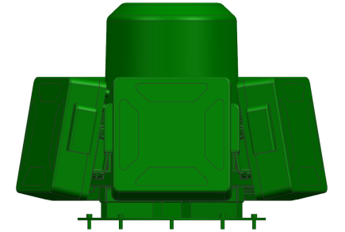 | 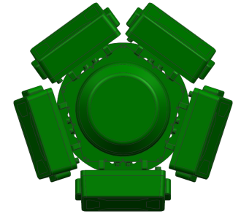
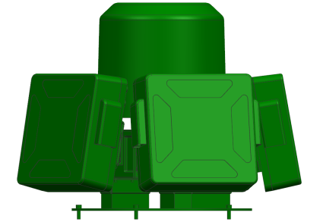 | 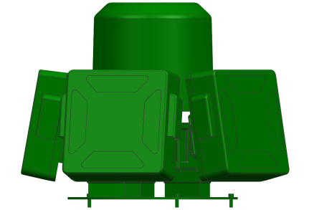
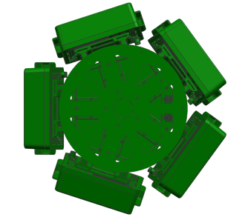 | 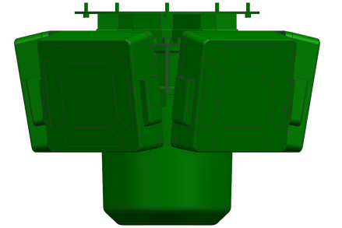

4.2 Product List

No. | Equipment name | Picture | Quantity | Weight（kg）
1 | Equipment main unit | 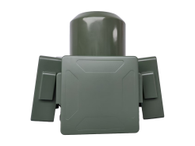 | 1 | 64.25
1.1 | Shield-type jamming unit | 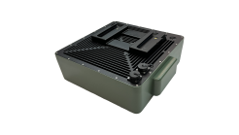 | 5 | 6.85
1.2 | Drone detection unit | 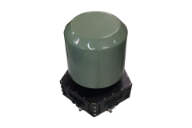 | 1 | 30
1.3 | Power supply system | 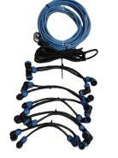 | 1 | 1.55
2 | Drone control and management system |  | 1
2.1 | IPC or laptop |  | 1
2.2 | Software |  | 1
3 | Aviation case
3.1 | Jamming aviation case | 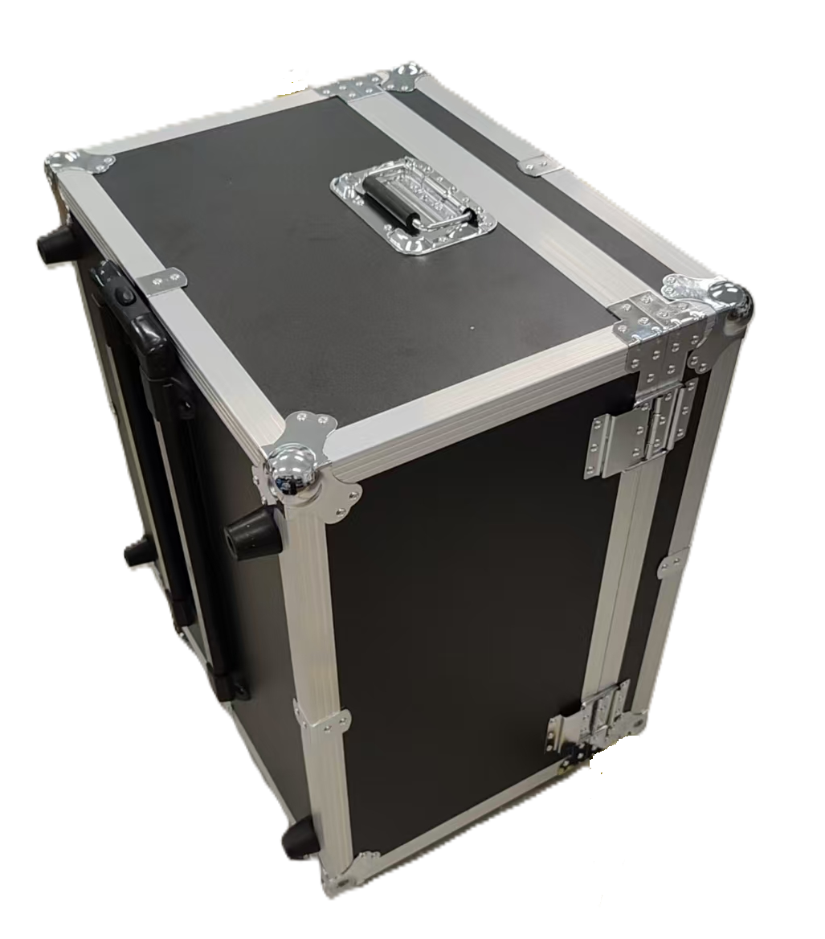 | 1 | 15.55
3.2 | Detection aviation case |  | 1 | 14.65
- Equipment Interface
Equipment data interface: LAN(RJ45), WAN(RJ45)
Equipment power supply interface: 3-core power cable (AC220V 50Hz)

5.1 Equipment Operation Interface
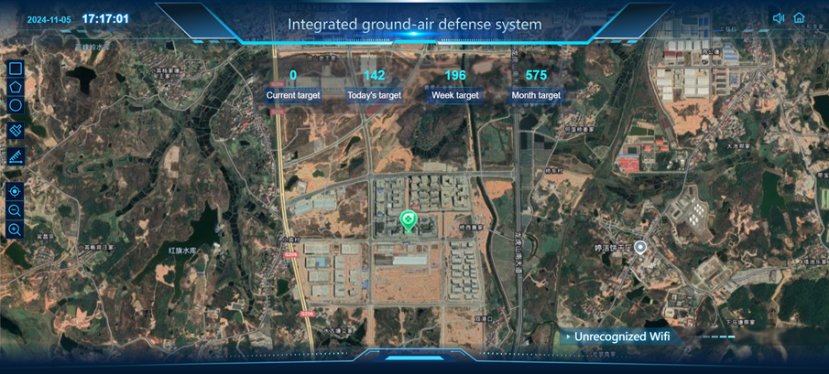

5.2 Equipment Safety Protection
Aviation case:
Jamming aviation case dimension：470mm*570mm*710mm
Detection aviation case dimension：680mm×600mm×480mm
